

**Department of Computer Science**

Semester VI

**SIBAU**

Submitted by: Madan Lal

**JAVA**

CMS ID: 053-18-0005

Instructor: Dr. Faheem Akhtar Rajput

Sukkur IBA University, Nisar Ahmed Siddique Road, Sukkur

**LAB # 01**

**Lab Tasks**

**Exercise 1 (JAVA Environment Installation & Error Messages)**

Set up a Java development environment. In the main() method of your program try to compile the following invalid Java code snippets. Record the error messages you receive. What do you think each error message indicates?

System.out.printn(“Hello World”)

System.out.printn(Hello World)

System.out.println”Hello World”;

println(“Hello World);

To generate one final error message, remove one of the brackets from the end of your program. Now what message do you receive?

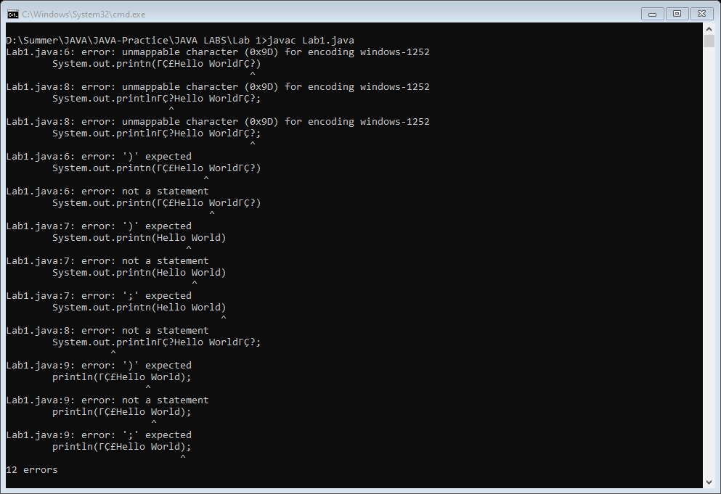

**Exercise 2 (Mathematical Expressions)**

Write Java code to identify if the given input by the user is even or odd.

import java.util.Scanner;

class Lab1

{

    public static void main(String args[])

    {

        Scanner input = new Scanner(System.in);

        System.out.print("Enter Number : ");

        int num = input.nextInt();

        if(num%2 == 0)

            System.out.println("Number is Even.");

        else

            System.out.println("Number is Odd.");

    }

}

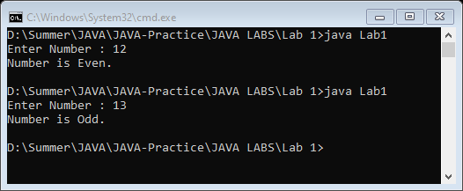

**Exercise 3 (Type casting)**

Perform division using two double variables and store the result in int variable and print the results

class Lab1

{

    public static void main(String args[])

    {

        double val1 = 3213121.12;

        double val2 = 12313.32;

        double result;

        result = val1/val2;

        int Result = (int)result;

        System.out.println(Result);

    }

}

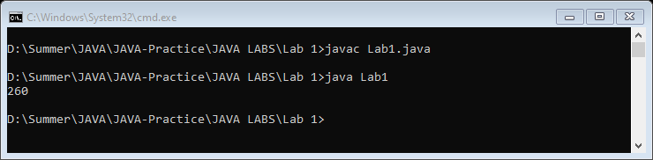

**Exercise 4 (Operators)**

Find largest among three numbers using if..else as well as operators statement

Enter value a:30

Enter value b:10

Enter value c:70

import java.util.Scanner;

class Lab1

{

    public static void main(String args[])

    {

        Scanner input = new Scanner(System.in);

        System.out.print("Enter value a : ");

        int a = input.nextInt();

        System.out.print("Enter value b : ");

        int b = input.nextInt();

        System.out.print("Enter value c : ");

        int c = input.nextInt();

        if(a > b && a > c)

            System.out.println(a+" is greater.");

        else if(b > a && b > c)

            System.out.println(b+" is greater.");

        else

            System.out.println(c+" is greater.");

    }

}

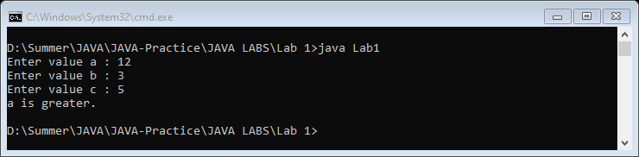

**Can you cast string into int?**

We can convert String to an int in java using Integer. parseInt() method. To convert String into Integer, we can use Integer. valueOf() method which returns instance of Integer class.

**Why JAVA when there are other OOP languages?**

Because you cannot write a simple program in Java without it being object-oriented. ... Unlike other programming languages like C++, JavaScript, and Python, OOP is optional whereas in Java it's really baked into the language as an essential part of Java.

**End of Lab 1**